Final Report – ECE 3027
Gage Farmer

Abstract – In this report we will discuss op-amps, and review several of their properties which were tested, and attempt to understand the connection between ideal and real situations. We will also discuss the differences between inverting and non-inverting, as well as what they have in common.

I. Introduction
Op-Amps are a crucial part of electronics, and their non-idealities such as non-infinite gain, input offset voltage, and output offset voltage each change how we can think to use the devices. Not only do they affect performance, but they can also result in unintended scenarios which have previously been harnessed in order to change the function of an Op-Amp within a certain application. Inverting and Non-Inverting Op-Amps may be similar in structure, however their behaviors differ greatly from one another in that they are almost complete opposites.

II. Op-Amps
When first explained, Op-Amps are generally described as having infinite open-loop gain, however this is not the case in practice. While high, the gain is finite, generally somewhere from 10,000 to 100,000 or even more, depending on the application. Since this gain is not infinite, the output voltage will not fully compensate for input offset, and this will cause a small deviation at the output. Input offset voltage is a small voltage used to make the output zero when the input should be zero. It essentially measures the asymmetry of the input of the Op-Amp, and when non-zero will affect the accuracy of the amplification. Offset output voltage on the other hand is the combined effect of the input offset voltage, non-ideal gain, and other layout imperfections. This is the actual offset observed at the output.
Used in conjunction, these non-idealities have been able to create things such as intentional circuit biasing. Instead of canceling the two offsets we use them in order to reduce the use of biasing components, and as a result can improve gain and slew rate. Having a limited gain and finite slew rate has also been used in waveform generation circuits in order to create triangle and sawtooth waveforms in oscillators. A bonus that wasn’t discussed in class but I had learned over the summer at my internship is known as thermal nrift. This is a result of the noise that occurs in an Op-Amp, and can be harnessed in order to introduce randomness or simulate real-world noise, very cool stuff.
When testing Op-Amps, the user knows their device is good when the output voltage is either close to zero or within a specified offset range. Otherwise the device is bad if the output voltage is too large, this usually means the device is damaged.

III. Types of Amplifiers
To first define the two types of amplifiers in this discussion, inverting amps are amplifiers in which the input signal is applied to the inverting terminal, and the non-inverting signal is attached to ground. This means the output will have a 180 degree phase shift from the input. On the other hand, non-inverting amps have the input signal connected to the non-inverting terminal with the inverting terminal connected to feedback. This results with the output being in phase with the input. The role of feedback in an inverting Op-Amp is to ensure that the input difference remains close to zero, which stabilizes gain. In a non-inverting Op-Amp, the purpose of feedback is to maintain phase consistency between Vin and Vout.
Comparing transfer functions in Equation 1 and Equation 2, we can see how the the ratio between feedback resistance and input resistance is negated for the inverting amplifier, whereas it is only added to 1 for the non inverting so it can be properly multiplied by input voltage for the resulting output voltage. Regarding NPN and PNP amplifiers, we see how the transfer function becomes a linear approximation of the gain within the active region. Adding feedback with the emitter resistor stabilizes gain and reduces distortion. Feedback via the emitter resistor stabilizes gain and reduces variability. Negative feedback in this configuration helps to linearize the gain response across different points in the circuit.
As shown in Equation 3, the differentiator Op-Amp functions by using the capacitor on the input signal to differentiate that as an output, and multiply the result by the resistance and capacitance applied in R and C. For the integrator transfer function we see it does the opposite in that it integrates the voltage as a function of time, then multiplies that by the negative inverse product of resistance and capacitance.
For Schmitt Triggers, the difference between inverting and non inverting is implied by the name. The output will change opposite to the input crossing threshold for the inverting trigger, and it will remain in phase with the non-inverting trigger. The purpose of Schmitt triggers is to create hysteresis using feedback, meaning the output will change based on thresholds rather than solely from input.

IV. Tables and Figures

Figure 1 – Op-Amp Symbol
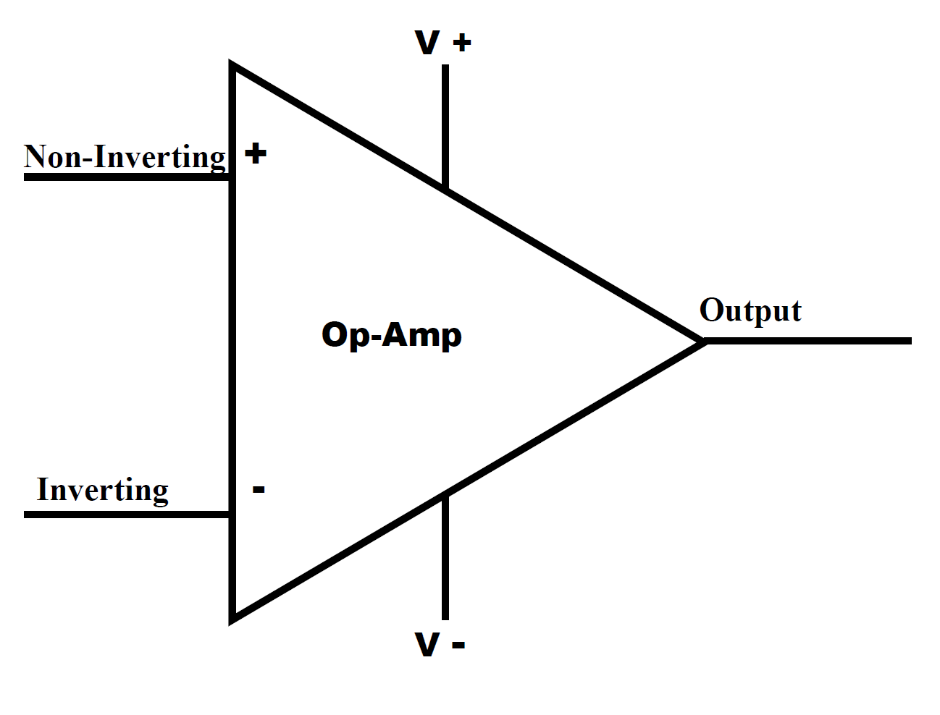
Figure 2 – Inverting vs Non-Inverting Op-Amps
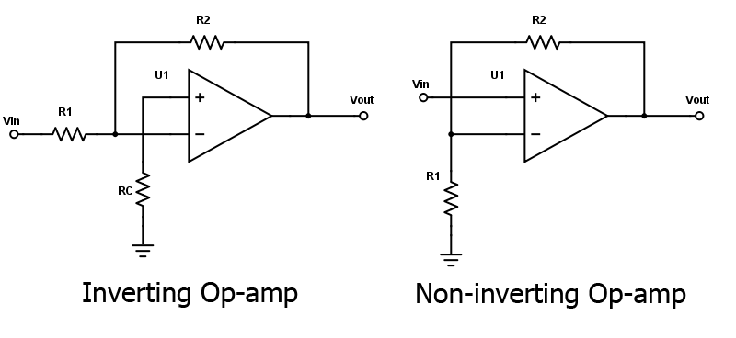
Figure 3 – Differentiator Op-Amp
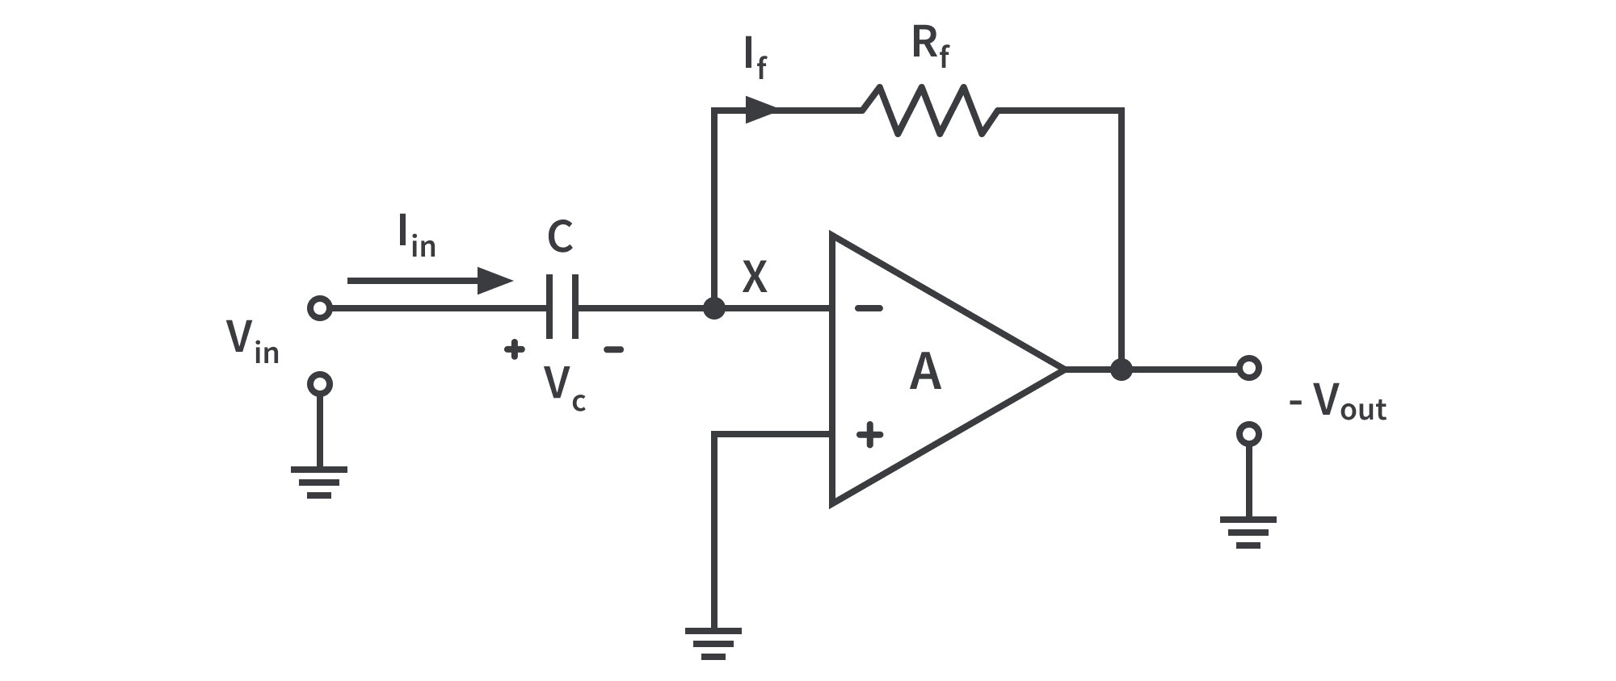
Figure 4 – Integrator Op-Amp
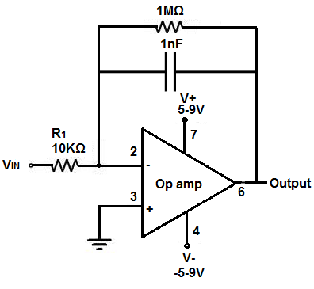
Figure 5 – Op-Amp Schmitt Trigger
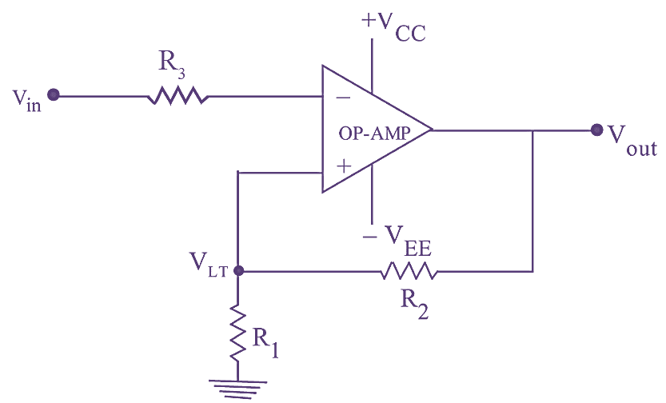

V. Equations

(1)
Inverting Op-Amp Transfer Function

(2)
Non-Inverting Op-Amp Transfer Function

(3)
Differentiator Op-Amp Transfer Function

(4)
Integrator Op-Amp Transfer Function

VI. Conclusion
To conclude, there are dozens of variations of the Op-Amp, all of which can be used for many different purposes and have their place in integrated circuit design. Inverting and non-inverting Op-Amps differ in the way one would expect, and have transfer functions which demonstrate that. Differentiator and Integrator Op-Amps are the same, in that their function is exactly as their name describes, and they function opposite of one another. Op-Amps themselves however are not limited to these four configurations, as they have other uses such as for things like biasing and thermal nrift.

References
[1] S. Franco, Design with Operational Amplifiers and Analog Integrated Circuits, 4th ed. New York, NY, USA: McGraw-Hill, 2014.
[2] F. Maloberti, Analog Design for CMOS VLSI Systems. New York, NY, USA: Springer, 2001.
[3] J. H. Huijsing, Operational Amplifiers: Theory and Design. New York, NY, USA: Springer, 2011.
[4] W. Sansen, Analog Design Essentials. New York, NY, USA: Springer, 2007.
[5] J. K. Roberge, Operational Amplifiers: Theory and Practice. New York, NY, USA: Wiley, 1975.
[6] "Integrator Op Amp Circuit," Learning About Electronics. http://www.learningaboutelectronics.com/Articles/Integrator-op-amp-circuit.php (accessed Nov. 18, 2024).
[7] "Inverting Op Amp Resistor Calculator," All About Circuits. https://www.allaboutcircuits.com/tools/inverting-op-amp-resistor-calculator/ (accessed Nov. 18, 2024).
[8] "Op Amps," AI Synthesis. https://aisynthesis.com/op-amps/ (accessed Nov. 18, 2024).
[9] "Op Amp Differentiator," CircuitBread. https://www.circuitbread.com/tutorials/op-amp-differentiator (accessed Nov. 18, 2024).

